Cover sheet for submission of
work for assessment

UNIT DETAILS
Unit name |  | Software Deployment and Evolution |  |  |  |  |  | Class day/time |  | ^{Office use only}
Unit code |  | SWE40006 |  |  | Assignment no. |  | 1 | Due date | 4 Sep 2026
Name of lecturer/teacher |  |  |  | Dr. Robina Tinawin
Tutor/marker’s name |  |  |  |  |  |  |  |  |  | _{Faculty or school date stamp}
STUDENT(S)
Family Name(s) |  |  |  |  |  | Given Name(s) |  |  |  | Student ID Number(s)
₍₁₎ | Chai |  |  |  |  | Yen Thung |  |  |  | 105025228
₍₂₎
₍₃₎
₍₄₎
₍₅₎
₍₆₎

DECLARATION AND STATEMENT OF AUTHORSHIP
- I/we have not impersonated, or allowed myself/ourselves to be impersonated by any person for the purposes of this assessment.
- This assessment is my/our original work and no part of it has been copied from any other source except where due acknowledgement is made.
- No part of this assessment has been written for me/us by any other person except where such collaboration has been authorised by the lecturer/teacher concerned.
- I/we have not previously submitted this work for this or any other course/unit.
- I/we give permission for my/our assessment response to be reproduced, communicated, compared and archived for plagiarism detection, benchmarking or educational purposes.
I/we understand that:
- Plagiarism is the presentation of the work, idea or creation of another person as though it is your own. It is a form of cheating and is a very serious academic offence that may lead to exclusion from the University. Plagiarised material can be drawn from, and presented in, written, graphic and visual form, including electronic data and oral presentations. Plagiarism occurs when the origin of the material used is not appropriately cited.
Student signature/s
I/we declare that I/we have read and understood the declaration and statement of authorship.
 | ₍₁₎ |  | ₍₄₎
 | ₍₂₎ |  | ₍₅₎
 | ₍₃₎ |  | ₍₆₎

Further information relating to the penalties for plagiarism, which range from a formal caution to expulsion from the University is contained on the Current Students website at www.swin.edu.au/student/
Copies of this form can be downloaded from the Student Forms web page at www.swinburne.edu.au/studentforms/ PAGE 1 OF 1

Task 1.1
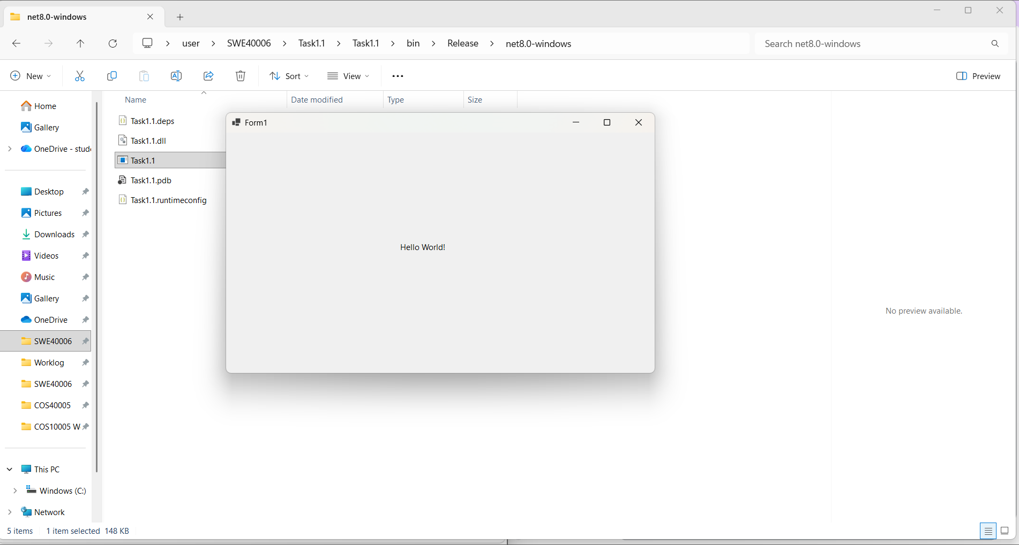
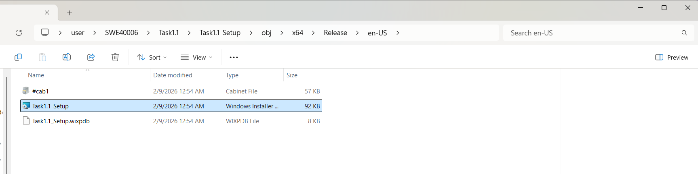
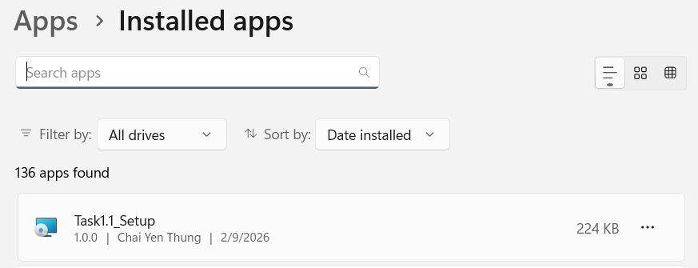

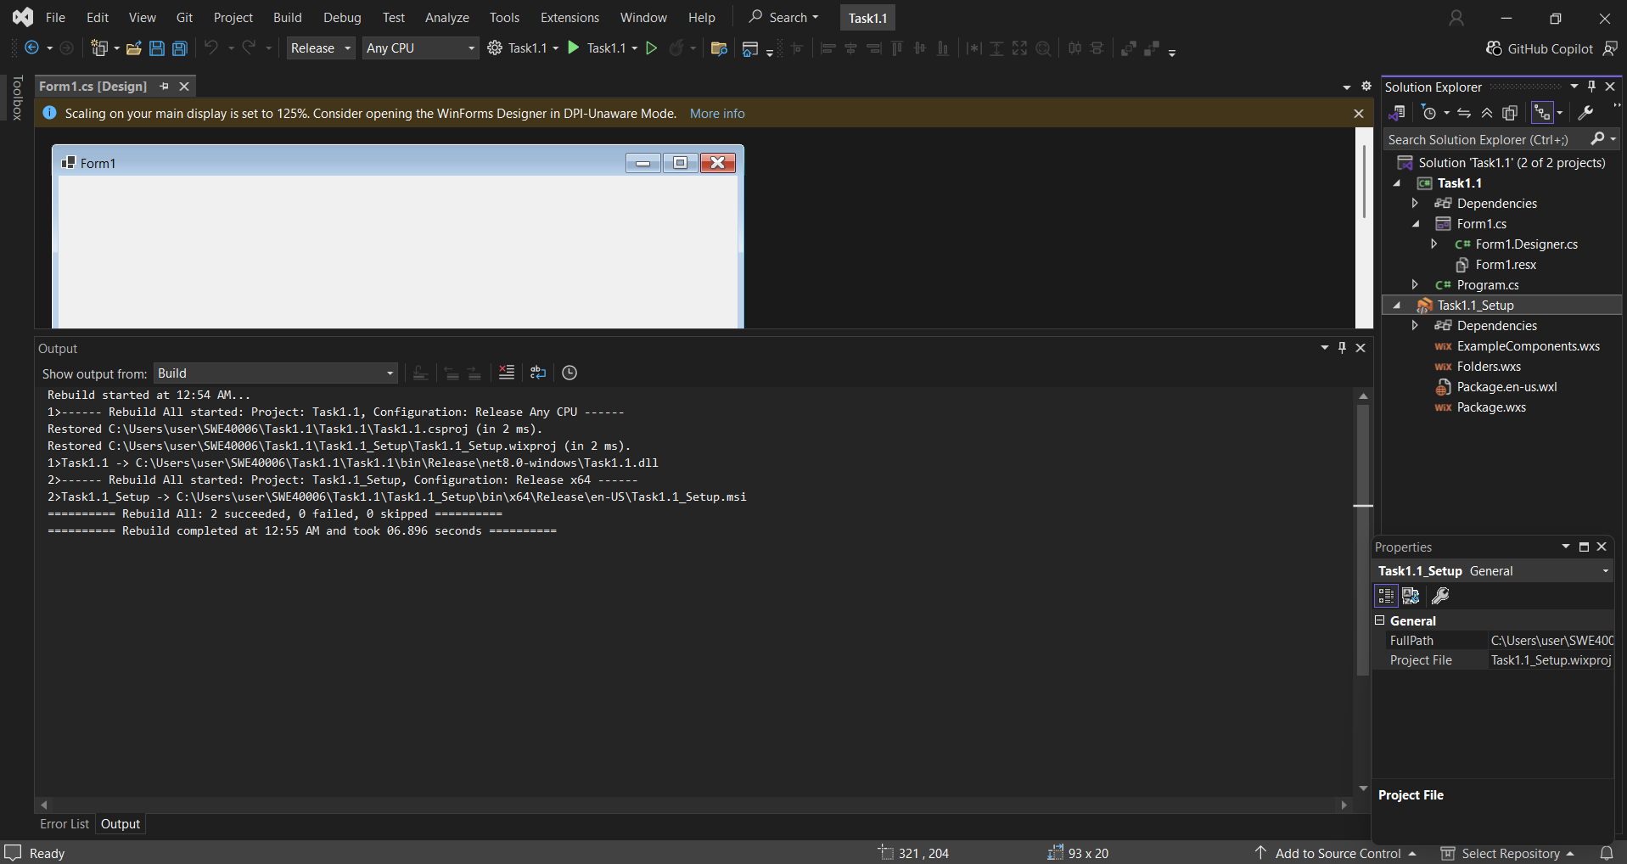

Task 1.2
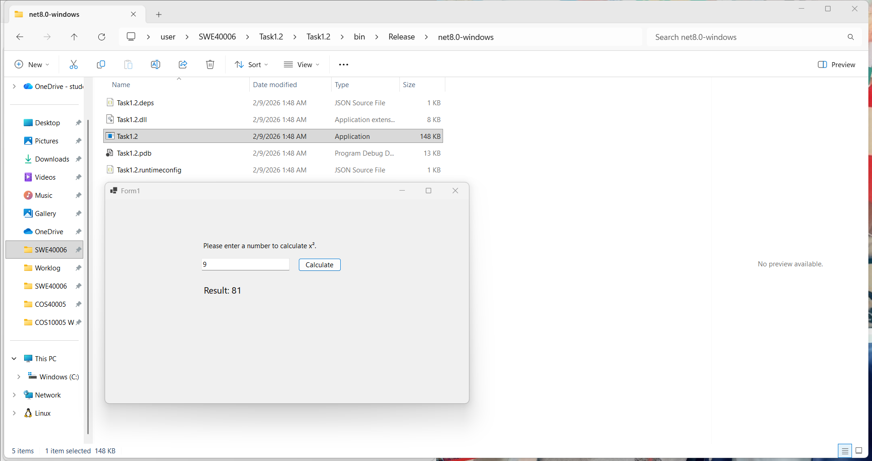
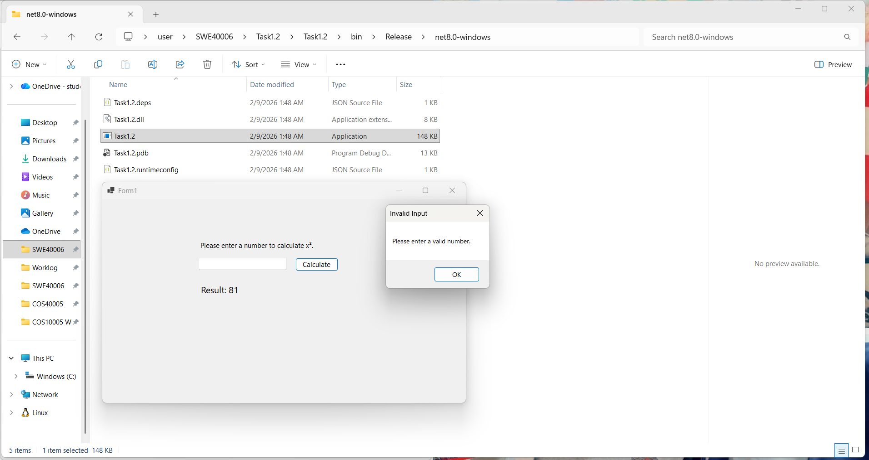
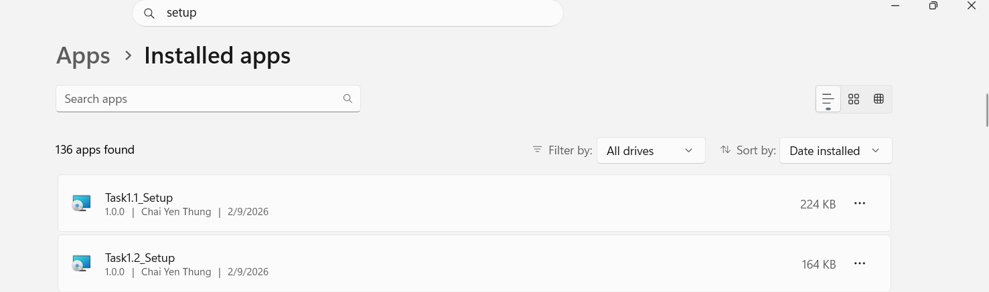
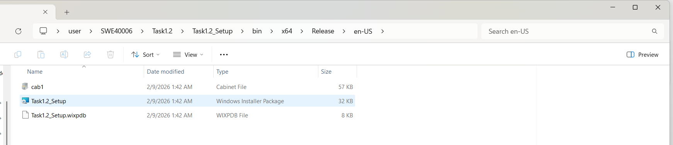
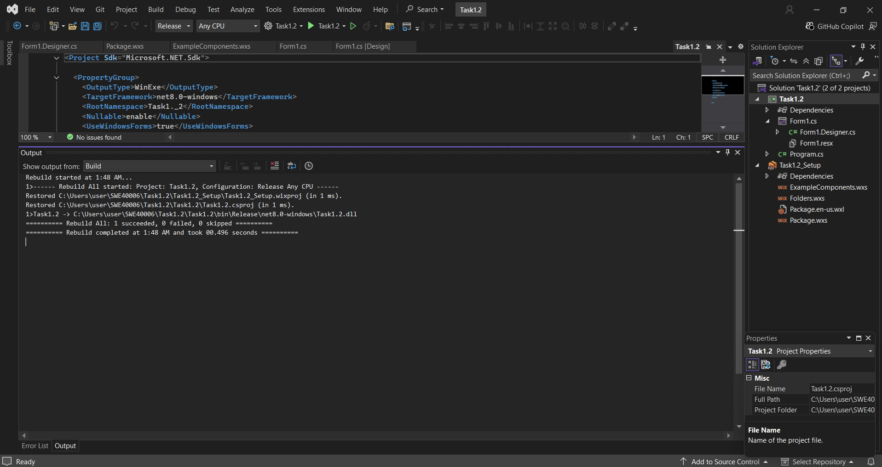
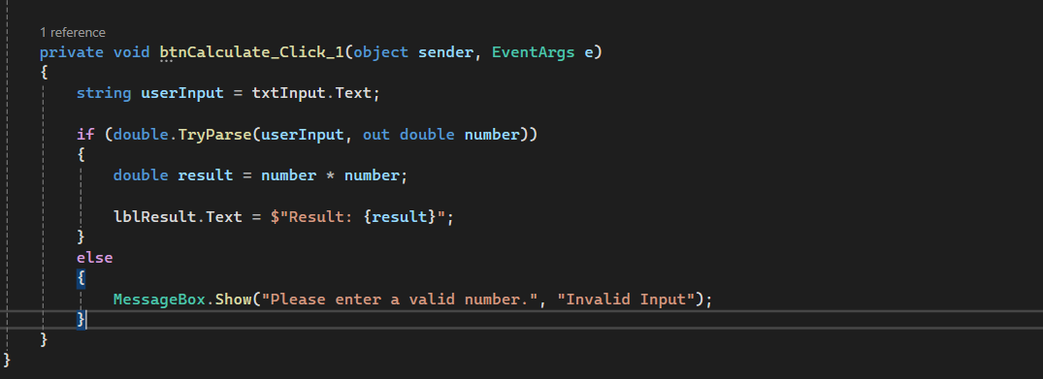

Task 1.3

